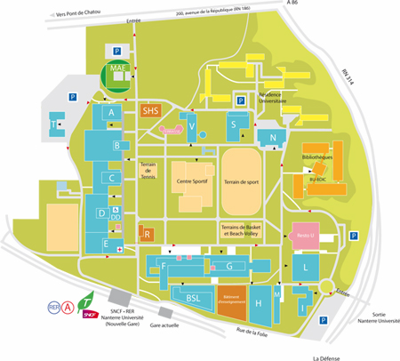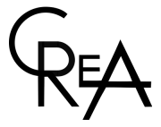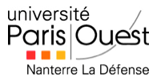

The conference will take place building V – room 506

(5th floor – please ask the porter for the lift)

Université Paris Ouest RER A Nanterre Université

Hotel Passy-Eiffel 10 rue de Passy 75016 Paris

Bar Le Passy 2 rue de Passy 75016 Paris

Restaurant La Citadelle 21 rue Médéric 75017 Paris

**An international conference – May 18th – May 21st, 2014**

**Organized by Bernard Zelechow, Avron Kulak, Marty Lockshin and Danièle Kahn**

**Université Paris Ouest**

**Room V 506**

**Twice Told Tales Truth, Fiction and Authority**

**Studies in Cultural Meaning**

**Centre de recherche sur les juifs anglophones**

With special thanks to the Faculty of Liberal Arts and Professional Studies and to the Israel and Golda Koschitzky Centre for Jewish Studies

**Monday 19th**

**Chair Person : Gerda Elata**

09:45 Cornelius Crowley Opening Speech

10:00 Brady Polka, The Authority of Fictive Truth and the Truth of Fictive Authority - On the Difference between Twice Told Tales in the Biblical and Greek Traditions

10:30 Marty Lockshin, Twice Told Biblical Stories and the Medieval Jewish Exegetes

11:00 Pause

11:30 Daniel Bodi, Why does David refrain from killing Saul twice ?

12:00 Laura Wiseman, Telling and Retelling Rachel

12:30 Lunch

**Chair Person : Danièle Kahn**

14:30 Iona Dureau, Shakespeare’s iconoclastic quotation of authority

15:00 Steven Bailey, Performance Anxiety : Social Dramas and the Abyss of Subjectivity

15:30 Pause

16:00 Julia Pascal on her experience as a female Jewish playwright in today’s Britain

**Tuesday 20th**

**Chair Person : Sara Horowitz**

10:00 Amila Buturovic, Trans-religious, Trans-gendered, Tans-historical - Cephalophore Martyrs in the Bosnian Cultural Imagination

10:30 Andrea Medovarski, Genre Without Boundaries – Transatlantic Slavery and Cultural Representations of the Zong Massacre

11:00 Pause

11:30 Margo Gewurtz, One wrong move : Lan Cao’s Monkey Bridge, a novel of Vietnamese American exile

12:00 Lunch

**Chair Person : Marty Lockshin**

14:30 Sara Horowitz, Holocaust Narratives as Midrash

15:00 Chaim Elata, A story told twice: My Autobiography/My Biography

15:30 Pause

16:00 SCM General Assembly

19:30 Gala Dinner Restaurant La Citadelle

**Wednesday 21st**

**Chair Person : Gideon Kouts**

10:00 Gideon Kouts, The Wanderings of the Lebanon: From Jerusalem to London

10:30 Selma Secevic, He Said, She Says : Court Tales, Legal Truth and Judicial Authority in the Early Nineteenth Century Sharia Court of Ottoman Sarajevo

11:00 Pause

11:30 Sonia Scott and Christopher Bradd, Truth, Crisis and Authority : Developing the Economic Imagination

12:00 Michelle Gewurtz, Televisual Truth Telling: Gender Meets Genre in *The Tunnel*

12:30 Lunch

**Sunday 18th**

6:00 – 8:00 pm : Welcoming Party - Bar Le Passy

Bar Le Passy – 2 rue de Passy 75016 Paris

Programme Day 2 and 3

Programme Day 1 and 2